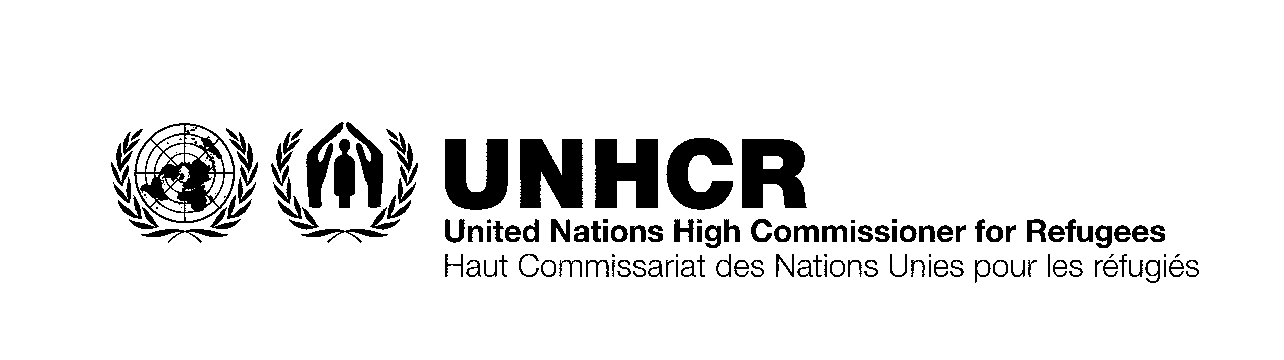

POETRY CONTEST

Topic: REFUGEES AND HUMAN RIGHTS

Eligibility: This contest is open to students in Grades 4-12 who are attending schools in the Greater Toronto Area. Poems will be written in English with a maximum of 24 lines. Awards will be given based on the following three grade categories for a total of three first prizes: Group I grades 4-5-6, Group II grades 7-8, Group III grades 9-10-11-12. Current employees or relatives of UNHCR Canada or COSTI Immigrant Services are not eligible to enter the contest.

Prizes: Three First Prizes of $200 each. Three Second and Third Prizes will receive $100 each.

Decisions: Judges will be members of the UNHCR Toronto Office, COSTI Immigrant Services, others to be announced. Entries will be judged on the basis of originality, creative imagination, characterization, artistic quality, adherence to the topic, and rules established for the contest. All decisions of the judges are final.

Fees: No entry fees and no purchases of any kind required to enter and win the contest.

Rights: All poems remain the property of the artist. By submitting a poem for this contest, the artist grants permission to UNHCR Canada and COSTI Immigrant Services to publish the poem, profile contest participants, and use submitted materials in any manner related to refugee and human rights promotion, including for World Refugee Day. UNHCR Canada and COSTI Immigrant Services are under no obligation to publish any contest entries. The artist is under no obligation to purchase a copy of the publication in which the poem may appear.

Notification: All prize winners will be notified and posted at www.costi.org

Winners will be invited to an open ceremony for prize awards and photo/interview opportunity, children younger than 16 will need to be accompanied by a responsible adult that can authorize and sign on their behalf.

For further information, contact: Emily Du; e.du@costi.org; 647-827-1297

Q. How does the contest work, and what prizes can I win?
A. UNHCR Canada and COSTI Immigrant Services are sponsoring the sixth annual Greater Toronto Area “Refugees and Human Rights Child and Youth Poetry Contest” to bring greater attention to human rights abuses and the plight of refugees. Each poem will be evaluated by our selection committee. There are three school grade categories, and in each category there is a prize for First ($200 each); Second ($100 each) and Third ($100 each). The grade categories are Group I grades 4-5-6, Group II grades 7-8, Group III grades 9-10-11-12.

Q. What is the topic and how do I enter the contest by mail?
A. Please enter only one original poem, 24 lines or fewer, on the subject any aspect of “Refugees and Human Rights”, in any style.

Due date: May 1, 2015. Please mail or email your poem to the following address:

Poetry Contest
1710 Dufferin Street, Toronto, ON M6E 3P2
Email: admin@costi.org

POETRY CONTEST ENTRY FORM

Participant Name:

School:

School Grade: |  | Age:

Home Address (Please include City and Postal Code)

Telephone: | Fax: |  | Email:

POEM TITLE:

POEM (24 lines or fewer)

CONSENT
I hereby declare that the attached poem is my original work and that all rights to this poem are mine. I am entering this poem as an honest and true effort of my personal creativity and unique artistic vision. By submitting a poem for this contest, the artist grants permission to UNHCR Canada and COSTI Immigrant Services to publish the poem, profile contest participants, and use submitted materials in any manner related to refugee and human rights promotion, including for World Refugee Day.
Participant Signature: Date:

Name of Parent/Guardian: (Please Print)

Parent/Guardian Signature: Date:

